Evaluation Metrics for Regression

When working with regression models, it's essential to evaluate their performance using appropriate metrics. These metrics help us understand how well the model is predicting the target variable and whether it generalizes well to unseen data. Below are the most commonly used evaluation metrics for regression

1. Mean Absolute Error (MAE)
Definition:
MAE measures the average absolute difference between the predicted values (Y^i) and the actual values (Yi​). It provides a straightforward interpretation of the average error.
Formula:
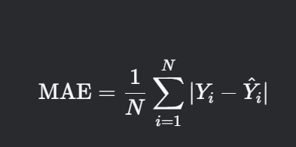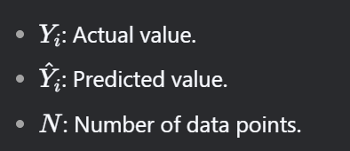

Interpretation:
- Lower MAE indicates better model performance.
- MAE is robust to outliers because it uses absolute differences.
Example:
If MAE = 3, the model's predictions are, on average, 3 units away from the actual values.
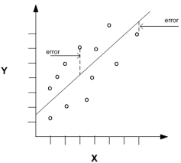
2. Mean Squared Error (MSE)
Definition:
MSE measures the average squared difference between the predicted values (Y^i​) and the actual values (Yi​). It penalizes larger errors more heavily than smaller errors.
Formula: 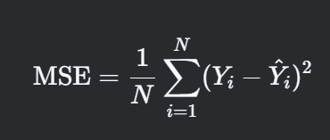
Interpretation:
- Lower MSE indicates better model performance.
- MSE is sensitive to outliers because it squares the errors.
Example:
If MSE = 25, the average squared error is 25.

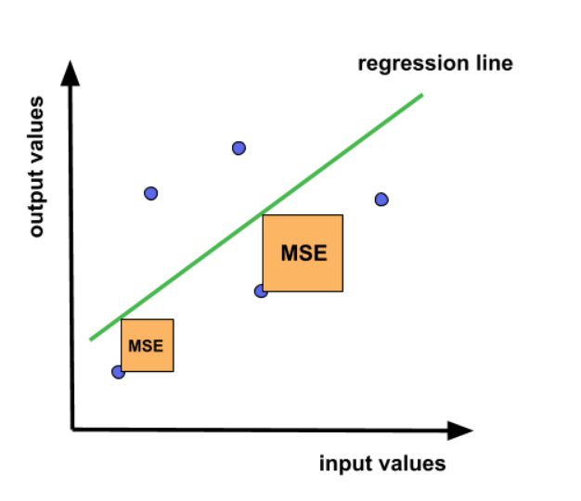

3. Root Mean Squared Error (RMSE)
Definition:
RMSE is the square root of MSE. It provides a measure of the average error in the same units as the target variable, making it easier to interpret.
Formula:
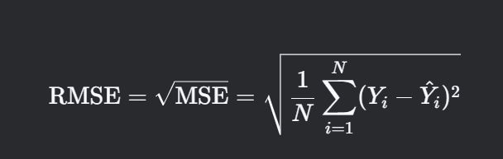
Interpretation:
- Lower RMSE indicates better model performance.
- RMSE is sensitive to outliers, similar to MSE.
Example:
If RMSE = 5, the model's predictions are, on average, 5 units away from the actual values.

4. R-squared (R²)
Definition:
R-squared measures the proportion of variance in the dependent variable (YY) that is explained by the independent variables (XX) in the model. It ranges from 0 to 1.

Formula:
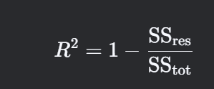

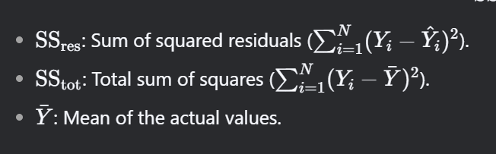

Interpretation:
- R2=1: The model explains all the variance in the target variable.
- R2=0: The model explains none of the variance.
- Higher R2 indicates better model performance.
Example:
If R2=0.85, the model explains 85% of the variance in the target variable.

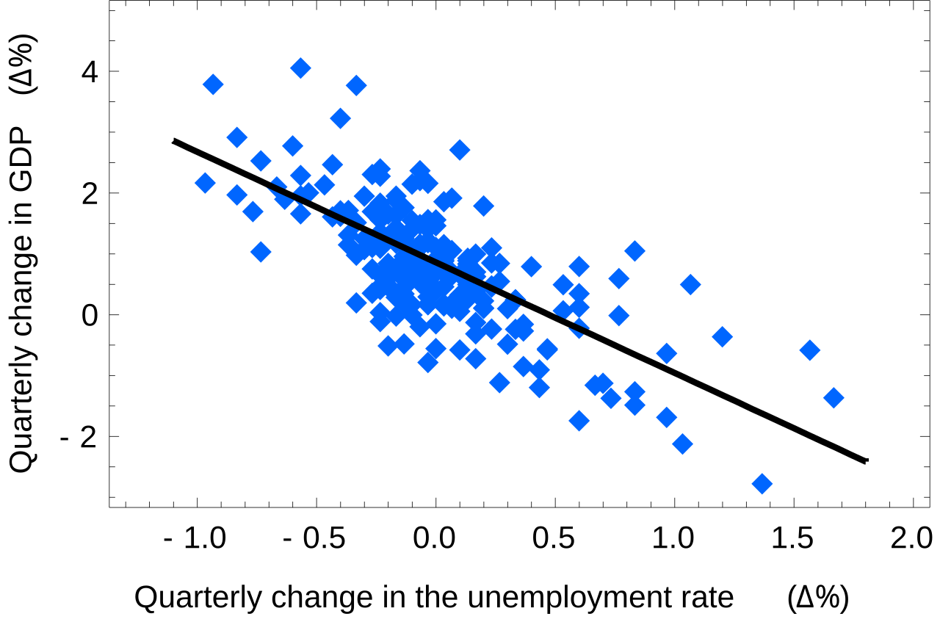

5. Adjusted R-squared (Adjusted R²)
Definition:
Adjusted R-squared adjusts the R2 value to account for the number of independent variables in the model. It penalizes the addition of unnecessary features that do not improve the model.
Formula: 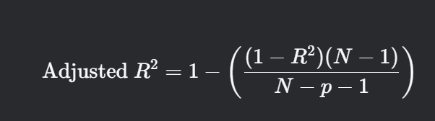

- N: Number of data points.
- p: Number of independent variables.
Interpretation:
- Adjusted R2 can be less than or equal to R2.
- Higher adjusted R2 indicates better model performance, considering the number of features.
Example:
If R2=0.85 and adjusted R2=0.83, the model explains 83% of the variance after adjusting for the number of features.

Comparison of Metrics
Metric | Interpretation | Sensitivity to Outliers | Units
MAE | Average absolute error. | Low | Same as target variable
MSE | Average squared error. | High | Squared units
RMSE | Square root of MSE. | High | Same as target variable
R² | Proportion of variance explained by the model. | N/A | Unitless
Adjusted R² | Adjusted proportion of variance explained, accounting for the number of features. | N/A | Unitless

When to Use Which Metric?
- MAE:
  - Use when you want a simple, interpretable measure of average error.
  - Use when outliers are present, as MAE is less sensitive to them.
- MSE/RMSE:
  - Use when larger errors should be penalized more heavily.
  - RMSE is preferred over MSE when you want the error in the same units as the target variable.

- R²:
  - Use to understand how well the model explains the variance in the target variable.
  - Use when comparing models with the same number of features.
- Adjusted R²:
  - Use when comparing models with different numbers of features.
  - Use to ensure that adding new features improves the model's performance.

